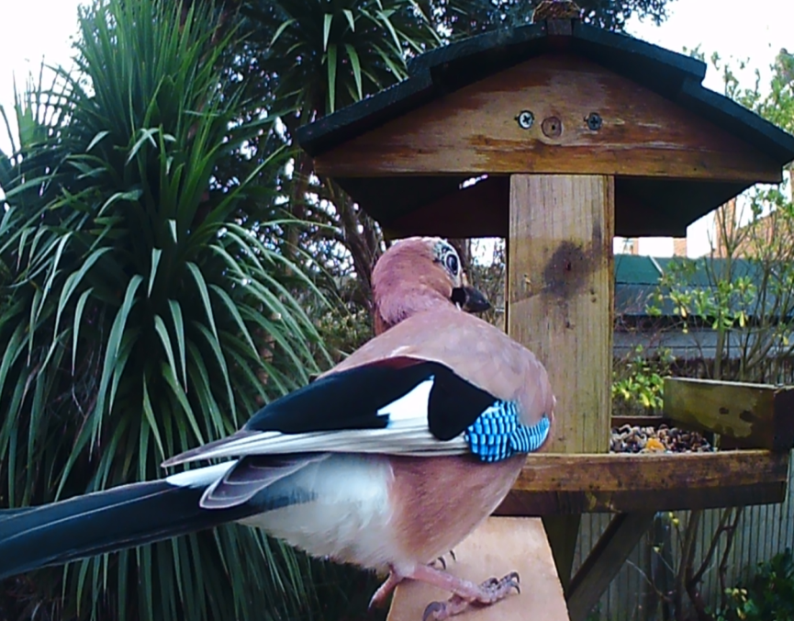
CONTEXT AND OBJECTIVES

My Mum’s bird table is designed to feed small garden birds like robins, tits, sparrows and finches but invariably the food is eaten by squirrels and pigeons before then can get to it. The main aim of this project is to create bird table that will detect the presence of visitors, identify whether or not they are welcome and repel any that aren’t. Small bird populations have fallen significantly in recent years and it is important that they eat as much of the food put out for them as possible.
The table will be attractive & stylish with a high quality finish made from plywood or solid wood shaped using a CAD router and with a waterproof finish. There will be a feeding platform and a bird bath. It will also have a waterproof container holding an electronic circuit comprising:
- An Arduino UNO board
- Arduino driven sensors to detect and identify animals
- Arduino driven devices to repel unwanted animals
The table will also have a wildlife camera mounted in a waterproof container to record visitors. The camera can take videos and this will allow the effectiveness of the repel circuit to be monitored and calibrated. The photos seen here were taken with the camera attached to my Mum’s bird table.
This project will also provide a platform that can help gather important information about small bird species and populations. This can help support scientific research such as the RSPB Big Garden Birdwatch. By repelling other animals the table will provide more data about the birds that the RSPB are most concerned about.
I interviewed my mother in order to perform some client research. Her requirements in order of importance were: Gets rid of large birds and squirrels / Is safe for animals to use / Will last a long time / Is attractive / Blends in with the garden / Has a bird bath

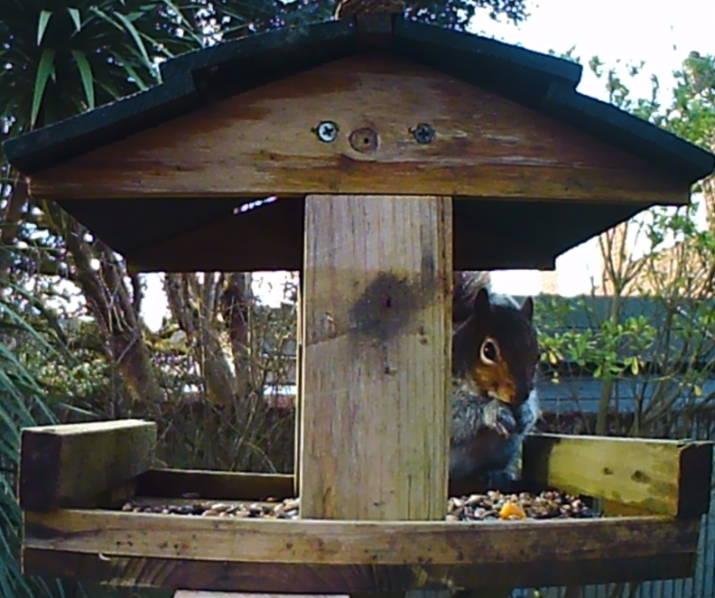
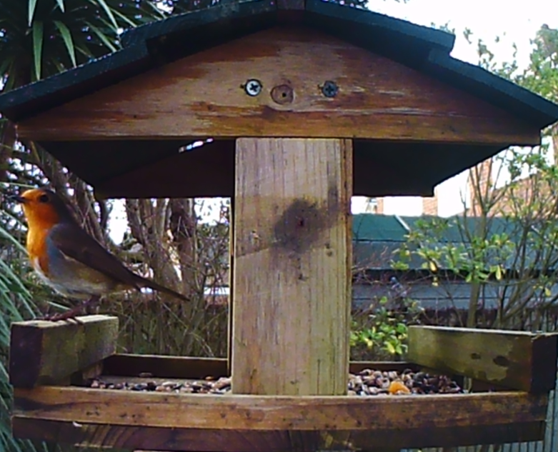

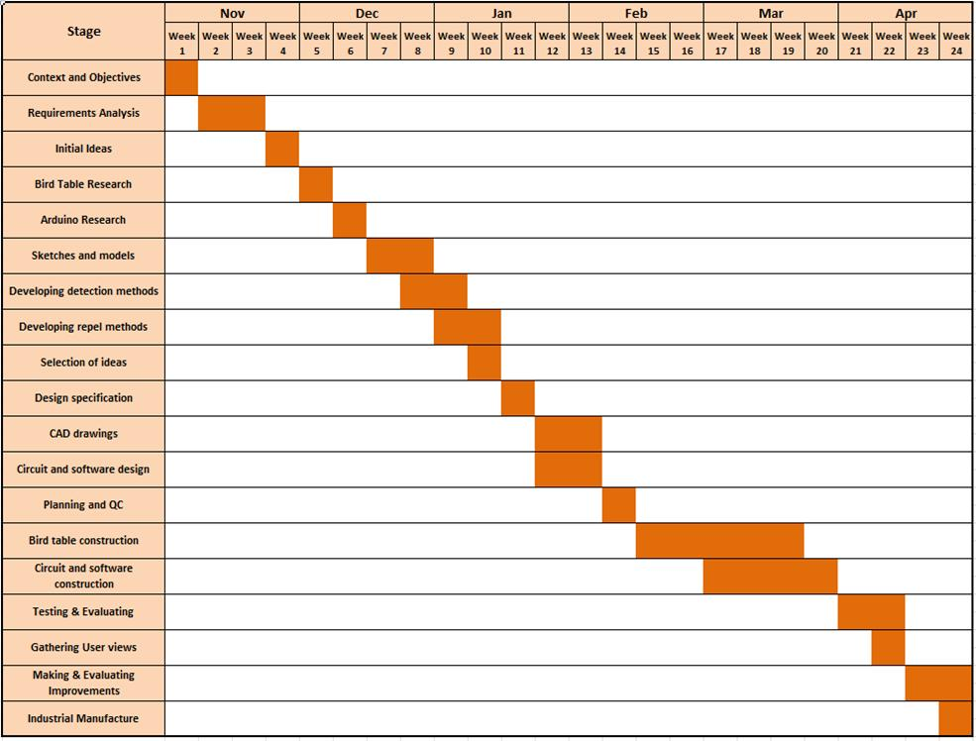
ACTION PLAN

